CV2 Midterm Exam Solution

(1) An ideal Lambertian surface is one that appears equally bright from all viewing directions and reflects all incident light absorbing none
Lambertian surface: perfectly diffusing surface with matte appearance

(2) time-varying vibration of the light energy in certain direction

(3) the amount of light falling on a surface
power per unit area of radiant energy falling on a surface
measured in units of watts per square meter.

(4) subtended by a surface patch is defined by the cone whose vertex is at the point of radiation and whose axis is the line segment going from the point of radiation to the center of the surface patch
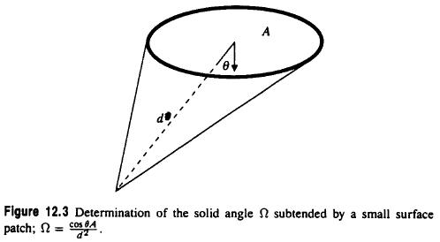
(5) apparent relative motion between objects and observer
points in observer’s direction of translation remain relatively unchanged information available to a moving observer

(6) assignment of vectors to image points representing motion

2. irradiance varies inversely as square of distance from the illuminated surface to source.

3. F, T, F

4. The straight lines in the real world are rendered as curved lines on image.
Barrel and pincushion.

5. Exterior Orientation: Determine position and orientation of camera in absolute coordinate system from projections of calibration points in scene
Interior Orientation: Determine internal geometry of camera
Relative Orientation: Determine relative position and orientation between 2 cameras from projections of calibration points in scene
Absolute Orientation: Determine transformation between 2 coordinate systems or position and orientation of range sensor in absolute coordinate system from coordinates of calibration points

6.  Take a nonlinear least-squares problem
● Linearize it by using Tylar expansion.
● Solve by iteratively solving successive linearized least-squares problems

7. 3, 3, 3, 2

8. Focus of expansion.

9. Optic flow is similar to motion filed, besides the special case.
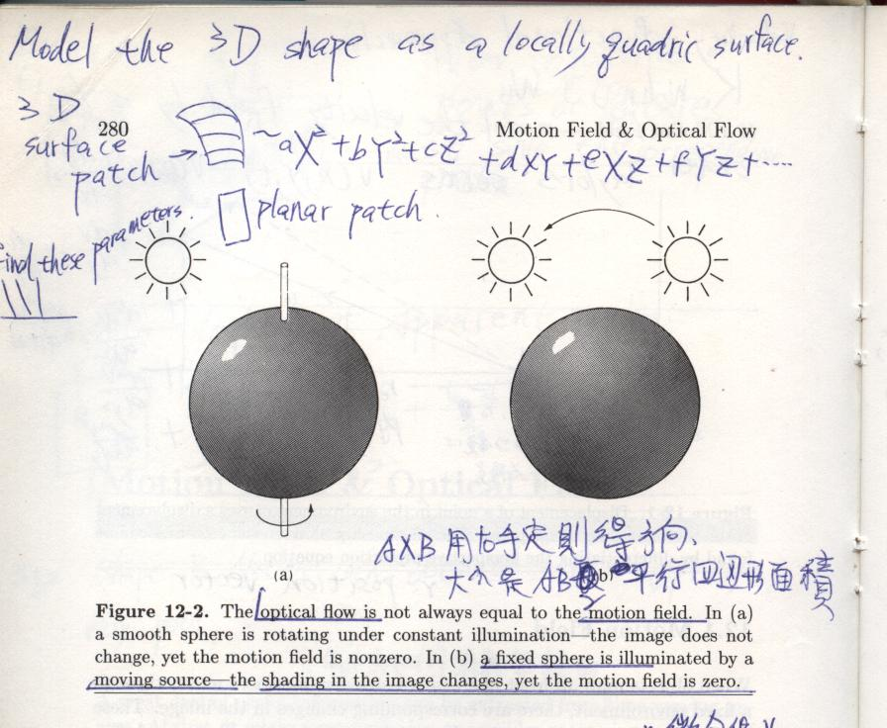

10. At approach point and at infinity (along horizon)

11.
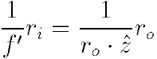
● ri: distance between perspectivity center and image point
● ro: distance between perspectivity center and object point
● f’: camera constant
z: depth axis, optic axis
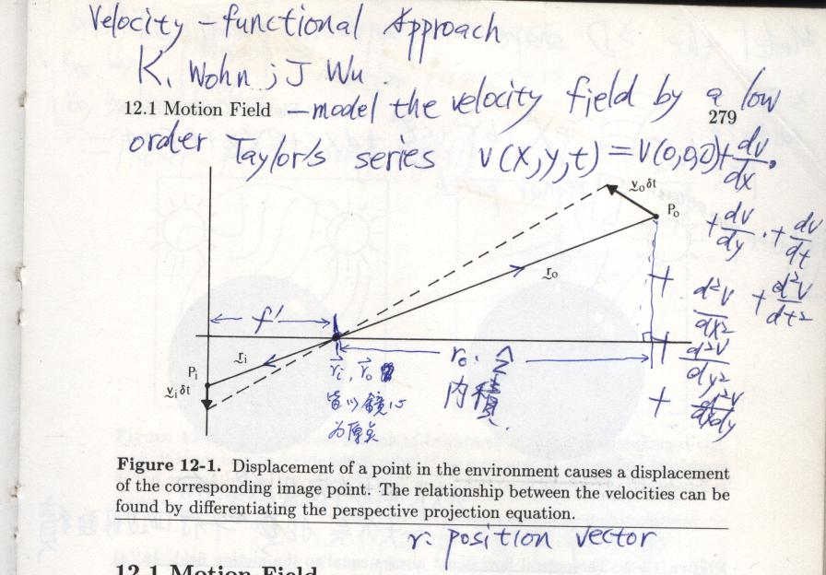
12.
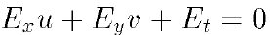
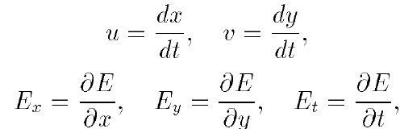

13.
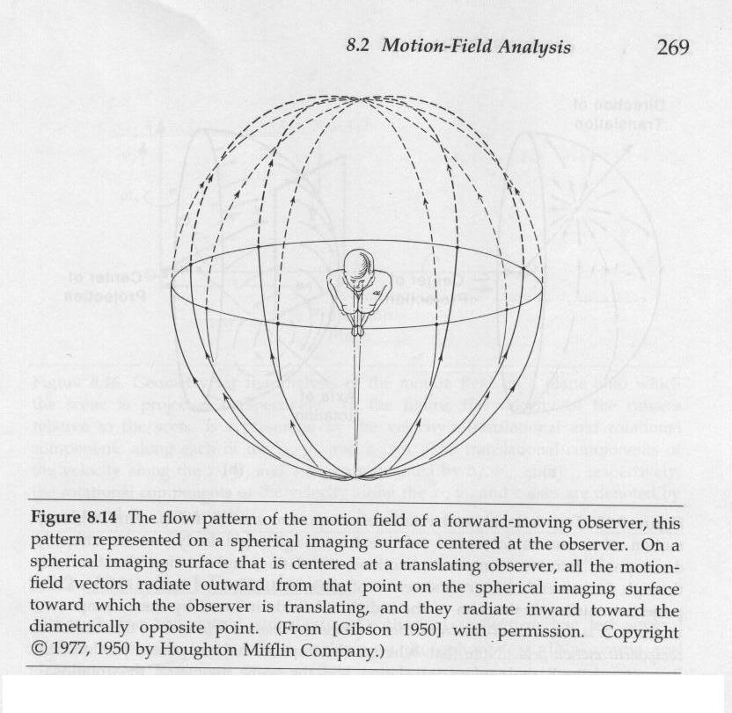
FOC: 人向前移動時和FOE相對稱的那點，而所有motion filed 都集中到此點。

14.
focus of expansion here: at infinity to the left
focus of contraction here: at infinity to the right of the figure

15.
kind of object
way objects are lit
background
kind of imaging sensor
viewpoint of the sensor

16.
